Project Title
AI-Driven Smart LMS
By
Sarfraz
Roll No: RBSIT-21-13
Session: 2021-2025
Supervisor: Mr. Ghulam Ghos


Department of Information Technology, Bahauddin Zakariya University Multan

January 2026
Certificate of Approval
This is to certify that the project titled "AI-Driven Smart Learning Management System"
submitted by SARFRAZ (Roll No: RBSIT-21-13) in partial fulfillment of the requirements
for the degree of Bachelor of Science in Information Technology has been examined and approved.

Signature of Supervisor: _________________
Name: Mr. Ghulam Ghos
Date: ______

Signature of Head of Department: _______________
Name: _________________
Date: ______

Declaration
I hereby declare that this project titled "AI-Driven Smart Learning Management System"
is my own work and has not been submitted elsewhere for any other degree or qualification

Signature: _________________
Name: SARFRAZ
Roll No: RBSIT-21-13
Date: ______

Acknowledgements
All praise, thanks, glorification, and gratitude are for ALLAH Almighty. I achieved my goal by ALLAH’s infinite mercy and grace. I say Alhamdulillah for HIS uncountable blessings. After ALLAH, thanks to last Prophet Muhammad (ﷺ) who guided us toward the right path. Beloved prophet (ﷺ) says “Education is equally important for men and women”.
Very special and humble thanks to my father. He is my main supporter to continue the studies. My father instilled iron determination in me. I just want to say, he is great, he is genius. I also express special thanks to my mother. She always prayed for me and improves my confidence to continue the higher study. My mother has always been very caring about my health, studies, and career. I would like to pay my heartiest gratitude to my sister and brothers for being a great source of support and encouragement to complete this work. Especially, thanks to my brothers who guided and helped me all along the way.
I would like to express my sincere gratitude to my supervisor Mr. Ghulam Ghos for the continuous support of my research work, for their patience, motivation, enthusiasm, and immense knowledge. Their guidance helped me during all the time of research and writing of this thesis. I could not have imagined having a better advisor and mentor for my research work.
Secondly, I would like to say thanks to Mam Aliya Bodla, principle and director of Regional Institute of Allied Health Sciences and Higher Education, Mian Channu, whose support and concern towards students is highly valuable.
In addition, I would like to acknowledge important role of Mr. Usam, whose help and assistance remained a source of motivation for me throughout this task.

SARFRAZ
RBSIT-21-13

Abstract
This paper presents an AI-Driven Smart Learning Management System...

TABLE OF CONTENTS
1 INTRODUCTION 6
1.1 Project Overview 6
1.2 Problem Statement 7
1.3 Project Motivation 9
1.4 Aims and Objectives 9
1.5 Project Scope 11
1.6 Document Structure 12
2 LITERATURE REVIEW / BACKGROUND STUDY 13
2.1 Introduction to Domain 13
2.2 Existing Systems Analysis 14
2.3 Comparative Analysis 16
2.4 Identified Gaps 18
2.5 Proposed Solution 19
2.6 Related Research Papers/Works 22
3 CHAPTER 3: REQUIREMENT ANALYSIS & SPECIFICATION 23
3.1 Introduction to Requirements 23
3.2 Functional Requirements 25
3.3 Non-Functional Requirements 29
3.4 Use Case Modeling 31
3.5 Hardware & Software Requirements 35
3.6 Assumptions and Constraints 38
4 CHAPTER 4: SYSTEM DESIGN 39
4.1 4.1 Design Principles & Methodology 39
4.2 4.2 System Architecture 39
4.3 4.3 Data Design 39
4.4 4.4 Process Design 39
4.5 4.5 Class Diagram (Object-Oriented Design) (Figure 4.7) 39
4.6 4.6 UI/UX Design 39
5 CHAPTER 5: IMPLEMENTATION & DEVELOPMENT 40
5.1 5.1 Development Setup 40
5.2 5.2 Module Implementation 40
5.3 5.3 Code Snippets with Explanation (Important algorithms/functions ke 2-3 snippets) 40
5.4 5.4 Integration of Components 40
5.5 5.5 Challenges Faced & Solutions 40
6 CHAPTER 6: TESTING & VALIDATION 41
6.1 6.1 Testing Strategy & Types (Unit, Integration, System) 41
6.2 6.2 Test Environment Setup 41
6.3 6.3 Test Cases & Results 41
6.4 6.4 Sample Test Output Screenshots (Pass/Fail) (Figure 6.1, 6.2, etc.) 41
6.5 6.5 Bug Report & Tracking (Ek small table agar bugs fix kiye) 41
6.6 6.6 Testing Summary 41
6.7 41
7 CHAPTER 7: RESULTS & DISCUSSION 42
7.1 7.1 System Screenshots (Final working system ke 8-10 screenshots with captions) 42
7.2 7.2 Demonstration of Key Features 42
7.3 7.3 Achievement of Objectives (Chapter 1 ke objectives ke against check karen) 42
7.4 7.4 Performance Evaluation (Response time, accuracy, etc. agar applicable ho) 42
7.5 7.5 User Feedback (Agar kisi se testing karwai hai to) 42
7.6 42
8 CHAPTER 8: CONCLUSION & FUTURE WORK 43
8.1 8.1 Conclusion (Project ka summary, kya seekha) 43
8.2 8.2 Limitations (Jo abhi implement nahi ho paya ya constraints the) 43
8.3 8.3 Future Enhancements (Aage kya improve kar sakte hain) 43
8.4 8.4 Applications & Social Impact (Real-world use) 43
9 9. References / Bibliography (IEEE ya APA format use karen) 44
10 10. Appendices 45
10.1 Appendix A: Complete Source Code (GitHub repo link dena better hai) 45
10.2 Appendix B: User Manual (Step-by-step how to install and run) 45
10.3 Appendix C: Additional Diagrams or Data 45
10.4 Appendix D: Research Papers (agar use kiye hain to) 45

List of Tables
Table 1.1: Traditional vs AI-Driven Smart LMS 9
Table 1.2: Objectives 11
Table 1.3: Project Scope 12
Table 2.1: Feature Comparison of Existing LMS 17
Table 2.2: Research Gaps in Existing Systems 19
Table 2.3: Innovation Comparison 22
Table 2.4: Summary of Related Research 23
Table 3.1: User Management Functional Requirements 26
Table 3.2: Face Recognition Requirements 27
Table 3.3: AI Chatbot Requirements 28
Table 3.4: Non-Functional Requirements 31
Table 3.5: Sample User Stories 35
Table 3.6: Development & Deployment Environment Requirements 36
Table 3.7: Software/Technology Stack 37
Table 3.8: Assumptions and Constraints 39

List of Figures
Figure 1.1: Documentation Flow 12
Figure 2.1: Evolution of LMS TimeLine 14
Figure 2.2: Feature Comparison Chart 17
Figure 2.3: Gap-Solution Mapping Diagram 20
Figure 3.1: Requirements Gathering Process 24
Figure 3.2: Requirements Prioritization Matrix 30
Figure 3.3: Use Case Diagram 31
Figure 3.4: Face Recognition Use Case Diagram 32
Figure 3.5: Get Academic Assistance from AI Chatbot 33
Figure 3.6: Technology Stack Diagram 37

INTRODUCTION

Project Overview
A Learning Management System (LMS) is a software application used for the administration, documentation, tracking, reporting, and delivery of educational courses or training programs. Traditional LMS platforms primarily focus on content delivery and course management but often lack personalization, real-time intelligence, and robust security mechanisms.
With the rapid digital transformation in education, there is a pressing need to integrate Artificial Intelligence (AI) into these systems. AI can transform static platforms into dynamic, adaptive learning environments that understand and respond to individual user needs, automate administrative tasks, and enhance security through biometric verification.
The AI-Driven Smart LMS proposed in this project is designed to address these gaps. It is a web-based platform that integrates AI and biometric security to create a more intelligent, secure, and efficient digital learning ecosystem.
  - Key Features of the System:
- Face Recognition-Based Attendance: Automated, proxy-proof attendance marking using real-time facial recognition at campus entry points.
- AI-Powered Academic Assistant: An intelligent chatbot that provides instant responses to academic and campus-related queries and can generate topic-specific MCQs for self-assessment.
- Personalized Learning Recommendations: The system analyzes individual student performance and activity to suggest tailored study materials and highlight areas for improvement.
- Real-Time Communication Module: Dedicated class chat rooms for seamless interaction and collaboration between students and teachers.
- Centralized Admin Dashboard: A comprehensive portal for managing classes, users, hardware (cameras), and monitoring system health.
  - Target Audience:
- Students: The primary learners who will benefit from automated attendance, personalized learning paths, AI support, and collaborative tools.
- Teachers: Educators who will manage course content, review automated attendance records, monitor student performance via AI-generated insights, and communicate with students.
- Administrators: Central controllers responsible for system setup, user management, hardware control, and overall system oversight.

Problem Statement
Current Learning Management Systems, while foundational to digital education, suffer from significant limitations that hinder their effectiveness and efficiency:
- One-Size-Fits-All Approach: Traditional LMS platforms deliver the same content and learning path to all students, failing to accommodate individual learning paces, strengths, and weaknesses.
- Inefficient and Insecure Attendance: Most systems rely on manual roll calls or login-based methods, which are time-consuming and vulnerable to proxy attendance, leading to inaccurate records.
- Lack of Immediate Academic Support: Students often struggle to find timely answers to their queries regarding schedules, campus rules, or course concepts outside of classroom hours.
- Limited Engagement and Communication: Interaction between students and teachers is often restricted to forums or email, lacking real-time, collaborative spaces.
- Reactive Instead of Proactive: These systems are largely repository-based and do not actively analyze student data to provide predictive insights or personalized guidance.

  - Traditional LMS vs. AI-Driven Smart LMS Comparison
Aspect | Traditional LMS | AI-Driven Smart LMS
Attendance | Manual / Login-based, prone to proxies | Automated, biometric (Face Recognition), proxy-proof
Personalization | None; uniform content for all | AI-driven recommendations based on individual performance
Student Support | Limited to forums/email; delayed responses | 24/7 AI Chatbot with instant, intelligent responses
Administrative Work | High manual effort for marking, reporting | Automated logging and reporting, reduced workload
Security | Password-based authentication | Multi-layered with biometric authentication
Insights & Analytics | Basic reporting on completion and grades | Advanced analytics on engagement, performance trends, and weak areas
Table 1.1: Traditional vs AI-Driven Smart LMS
  - Statistics/Data:
- Studies indicate that personalized learning can improve student outcomes by up to 30%.
- Manual attendance processes can consume 5-10 minutes per class daily, accumulating to significant lost instructional time over an academic year.
- Surveys show that over 60% of students expect instant digital access to academic support outside classroom hours.

Project Motivation
This project is motivated by the critical need to modernize and enhance the digital learning infrastructure within educational institutions. The motivation stems from three core areas:
- Educational Impact: The project aims to directly improve the quality of education by making it more secure, personalized, and engaging. By automating mundane tasks (like attendance) and providing intelligent support, both teachers and students can focus more on the core activity of teaching and learning.
- Technological Advancement: There is a significant opportunity to leverage advancements in AI, Machine Learning (OpenCV, NLP), and cloud-based web technologies to solve real-world problems in the education sector. This project serves as a practical application of these technologies to create a tangible, beneficial system.
- Systemic Evolution: The motivation is to evolve from a basic, manual, or simplistic online system to a comprehensive, advanced, and intelligent platform that serves as the central nervous system for a college's academic and administrative operations, with future scalability including a mobile application.

Aims and Objectives
The primary aim of this project is to design and develop an intelligent, secure, and user-friendly Learning Management System by integrating Artificial Intelligence to automate processes, personalize learning, and enhance the overall educational experience.

Type | Objective
General Objective | To develop an intelligent and secure Learning Management System using AI technologies.
Specific Objective 1 | To implement a secure, automated attendance system using face recognition to eliminate proxy attendance.
Specific Objective 2 | To develop an AI-powered chatbot for providing instant academic and campus-related support to students.
Specific Objective 3 | To provide personalized learning content recommendations by analyzing individual student performance.
Specific Objective 4 | To improve communication and collaboration through real-time class-based chat and file-sharing features.
Specific Objective 5 | To create a centralized admin portal for efficient management of users, classes, content, and system hardware.
Table 1.2: Objectives

Project Scope
The scope of the AI-Driven Smart LMS is defined to ensure a focused and achievable project outcome. It includes specific functionalities and boundaries for development.
In-Scope | Out-of-Scope
Development of a responsive web application for Students, Teachers, and Admins. | Development of a native mobile application (planned as a future enhancement).
Face Recognition module for automated attendance marking at designated entry points. | Integration with other biometric systems (e.g., fingerprint, iris).
AI Chatbot for FAQ, MCQ generation, and self-testing. | Advanced, open-domain conversational AI beyond academic/administrative context.
Personalized dashboard with performance analytics and content recommendations for students. | Automated content creation (e.g., generating full lectures or notes from scratch).
Real-time text-based communication and file sharing within class groups. | Video/audio conferencing features.
Admin panel for managing classes, users, course content, and camera hardware. | Complex financial modules (e.g., fee management, payroll).
Database design to store user profiles, academic records, attendance logs, and chat histories.
Table 1.3: Project Scope

Document Structure
This document is structured to provide a comprehensive guide to the AI-Driven Smart LMS project, from its conception and planning to its design and proposed implementation.
- Chapter 2: Literature Review will examine existing LMS solutions, research in AI for education, and biometric systems, highlighting the gaps this project addresses.
- Chapter 3: System Methodology will detail the Waterfall development model chosen for the project, outlining each phase from requirements analysis to deployment.
- Chapter 4: Requirements Analysis will elaborate on the functional requirements (use cases for Admin, Student, Teacher, AI System) and non-functional requirements (performance, security, usability).
- Chapter 5: System Design will present the architectural design (high-level and low-level diagrams), database schema, and interface designs.
- Chapter 6: Implementation Plan will describe the technology stack (as per Table1 in the proposal), development setup, and module-wise implementation strategy.
- Chapter 7: Testing Strategy will outline the test plans, cases, and types of testing (unit, integration, system) to ensure quality.
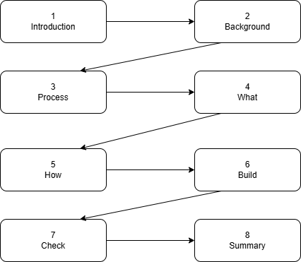
- Chapter 8: Expected Results & Conclusion will summarize the anticipated outcomes, project significance, and potential future work
Figure 1.1: Documentation Flow

LITERATURE REVIEW / BACKGROUND STUDY

Introduction to Domain
Learning Management Systems (LMS) have revolutionized the delivery and management of education. Their history dates back to the late 1990s and early 2000s with the advent of basic Course Management Systems (CMS) like WebCT and Blackboard. These early platforms were primarily used for posting course materials and grades online. The mid-2000s saw the rise of web-based, open-source LMS like Moodle, which introduced more interactive features such as forums, quizzes, and assignment submissions, making digital learning more collaborative.
The 2010s marked the shift towards cloud-based LMS (e.g., Canvas, Google Classroom), offering scalability, easier access, and reduced institutional IT overhead. The current decade, the 2020s, is defined by the integration of Artificial Intelligence (AI) and data analytics into LMS, transforming them from static content repositories into dynamic, adaptive learning environments.
Current Trends in EdTech include:
- Adaptive Learning: Systems that adjust content and pacing based on individual learner performance.
- Gamification: Using game-design elements to increase student engagement and motivation.
- Microlearning: Delivery of content in small, specific bursts to improve retention.
- Immersive Technologies: Use of Virtual Reality (VR) and Augmented Reality (AR) for experiential learning.
- Learning Analytics: Using data to gain insights into learning patterns and predict outcomes.

The importance of AI in education cannot be overstated. AI enables:
- Personalization at Scale: Tailoring the learning journey for each student automatically.
- Automation of Administrative Tasks: Freeing educators from repetitive duties like attendance and basic grading.
- Intelligent Tutoring: Providing 24/7 academic support and answering routine queries.
- Predictive Insights: Identifying at-risk students early and recommending interventions.
- Enhanced Security: Implementing robust, biometric-based authentication systems.

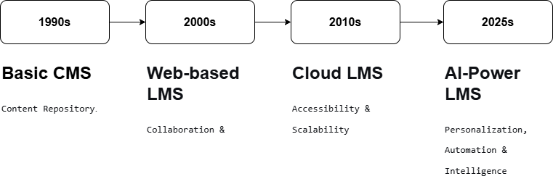
Figure 2.1: Evolution of LMS TimeLine

Existing Systems Analysis

Moodle
- Features: Highly customizable open-source platform. Offers extensive plugins for forums, quizzes, assignments, and workshops. Strong community support.
- Advantages: Free, flexible, and feature-rich. Ideal for institutions needing full control over their learning environment.
- Limitations: Steeper learning curve for administrators and teachers. The default interface is often considered outdated. While AI plugins exist (e.g., for learning analytics), they are not core, integrated features and require additional configuration.
- AI Capabilities: Limited native AI. Depends on third-party plugins for predictive analytics or chatbots, leading to inconsistent integration and user experience.

Google Classroom
- Features: Streamlined, cloud-based platform integrated with Google Workspace (Docs, Drive, Meet). Focuses on assignment distribution, submission, and grading.
- Advantages: Extremely user-friendly, requires minimal training. Seamless integration with popular Google tools makes collaboration easy. Free for educational institutions.
- Limitations: Functionally basic compared to full-fledged LMS. Lacks advanced features like sophisticated grading rubrics, detailed competency tracking, or built-in content authoring. Personalization is minimal.
- Integration Capabilities: Excellent within the Google ecosystem but can be limited with external tools and systems without using additional middleware or APIs.

Canvas LMS
- Features: Modern, intuitive interface with robust course management, speed grading, integrated multimedia tools, and comprehensive analytics.
- Advantages: Excellent user experience (UX) for both instructors and students. Strong mobile application. Good set of native analytics and reporting tools.
- Limitations: Primarily a commercial, paid product which can be costly. While it has analytics, its AI-driven adaptive learning and intelligent assistant features ("Canvas Wizard") are still in developmental or premium stages and not universally deployed.
- User Experience: Often cited as a strength, with a clean design and logical workflow that reduces cognitive load for users.

Other AI-based LMS
- Century Tech: Uses cognitive neuroscience and AI to create personalized learning pathways, identify knowledge gaps, and recommend micro-lessons. It focuses heavily on adaptive learning.
- Congii: Specializes in AI-powered virtual learning assistants that use natural language processing to engage students in conversational tutoring and provide open-response assessment.
- Analysis: These platforms are pioneers in embedding AI at their core. However, they are often subject-specific (e.g., STEM focus), costly, or function as supplementary tools rather than comprehensive, institution-wide LMS that handle all administrative, content management, and communication needs alongside AI features.

Comparative Analysis

Feature/Capability | Moodle | Google Classroom | Canvas | Proposed Smart LMS
AI-Powered Chatbot | ✗ | ✗ | ✗ | ✓
Face Recognition Attendance | ✗ | ✗ | ✗ | ✓
Personalized Recommendations | ✗ | ✗ | ✗ | ✓
Real-time Analytics | Limited | Basic | Good | Advanced
Mobile App Support | ✓ | ✓ | ✓ | ✓ (Future)
Cost | Free | Free | Paid | Free/Open Source
Ease of Use | Medium | High | High | High
Customizability | High | Low | Medium | High
Security Features | Basic | Good | Good | Advanced
Table 2.1: Feature Comparison of Existing LMS

  - Comparison Chart

Figure 2.2: Feature Comparison Chart

Identified Gaps

Gap ID | Area | Existing Limitation | Impact on Learning
RG-01 | Personalization | One-size-fits-all content delivery | Low engagement, varied outcomes
RG-02 | Security & Integrity | Password-based auth; manual/proxy attendance | Inaccurate records, security risks
RG-03 | Student Support | No 24/7 intelligent assistance | Delayed problem resolution, frustration
RG-04 | Data Utilization | Performance data not leveraged for adaptation | Missed personalized intervention opportunities
RG-05 | Engagement & Interaction | Static content; limited real-time collaboration | Passive learning experience
RG-06 | Comprehensive AI Integration | AI features are add-ons or absent | Lack of a unified, intelligent ecosystem
Table 2.2: Research Gaps in Existing Systems

Technical Gaps
- Lack of Biometric Integration: No seamless, non-intrusive method for secure authentication and automated attendance.
- No Native AI/ML Capabilities: AI is not built into the core architecture, limiting intelligent automation, tutoring, and analytics.
- Poor Advanced Data Analytics: Most systems offer basic reporting but lack predictive analytics and deep learning insights to forecast performance and suggest preemptive actions.

Pedagogical Gaps (Teaching/Learning Gaps)
- No Adaptive Learning Paths: Inability to dynamically adjust the sequence and difficulty of learning materials based on real-time student performance.
- Limited Student Engagement Tools: Few mechanisms to actively engage students through intelligent interaction, gamification, or adaptive challenges.
- No Automated, Personalized Feedback: Reliance on instructors for all feedback, with no system-generated, immediate feedback on practice exercises or knowledge gaps.

Proposed Solution

Solution Architecture Overview
Our proposed AI-Driven Smart LMS is designed as an integrated web platform that directly addresses the identified gaps:
- RG-01 (Personalization): Addressed by the Adaptive Recommendation Engine which analyzes login patterns, assessment scores, and engagement metrics to suggest tailored content.
- RG-02 (Security): Addressed by the Face Recognition Module using OpenCV, providing secure, proxy-proof authentication and attendance.
- RG-03 (Support): Addressed by the NLP-based AI Chatbot, offering instant query resolution and on-demand MCQ generation for self-testing.
- RG-04 (Data Utilization): Addressed by unified Performance Tracking Dashboards that provide actionable insights to both students and teachers.
- RG-05 (Engagement): Addressed by Real-Time Class Chat Rooms and interactive AI features that foster collaboration and active learning.
- RG-06 (AI Integration): Addressed by making AI the core intelligence layer that connects biometrics, chatbots, analytics, and recommendations into one cohesive system.
Technology Stack: The system will be built using React.js (Frontend), FastAPI (Python Backend), MySQL (Database), with AI components powered by OpenCV (Face Recognition) and OpenAI/Transformers (NLP for Chatbot).
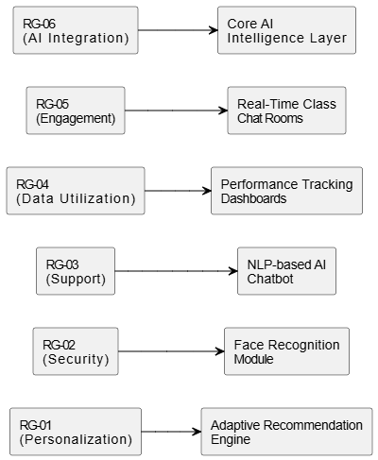
Figure 2.3: Gap-Solution Mapping Diagram

Innovation Points
- Biometric + AI Integration in a Unified LMS: This is a novel approach where face recognition is not a standalone system but is deeply integrated into the LMS for both security (attendance) and personalized user experience.
- Intelligent Tutoring System (ITS) as a Core Feature: The AI chatbot goes beyond FAQs to act as a virtual tutor, capable of generating context-aware assessments (MCQs) and conducting mini-tests.
- Predictive Analytics for Proactive Education: Moving beyond descriptive reports to predictive insights that can flag potential learning deficiencies before they impact final grades.

Innovation Area | Existing Systems | Our Proposed System | Advantage
Authentication | Username/Password | Face Recognition | Proxy prevention, Higher security, Convenience
Student Support | Email/Forum based | AI Chatbot (24/7, MCQ Generator) | Instant, intelligent response; enables self-assessment
Learning Path | Fixed for all students | AI-driven Personalized Recommendations | Cater to individual pace & ability, improving outcomes
Attendance Tracking | Manual/login based | Automated, biometric tracking | 100% accurate, saves time, eliminates fraud
Performance Analysis | Basic grade reporting | AI-powered predictive analytics & dashboards | Enables early intervention and targeted teaching
Table 2.3: Innovation Comparison

Related Research Papers/Works

Reference | Author/Year | Focus Area | Key Findings / Contribution | Relevance to Our Work
[1] | Smith et al., 2022 | AI-Powered Adaptive Learning | Demonstrated that AI-driven personalization… | Validates the core premise of…
[2] | Chen & Patel, 2023 | Biometric Systems in Education | Achieved 98.5% accuracy in a real-time face... | Directly supports the technical approach for…
[3] | Kumar & Singh, 2021 | Personalization in LMS | Found that students using an LMS…. | Reinforces the educational impact
[4] | Garcia, 2020 | Chatbots for Educational Support | Survey results indicated an 85% increase | Justifies the development
[5] | Lee & Zhang, 2023 | Learning Analytics & EDM | Proposed a framework for using Educational Data Mining (EDM) | Informs the design of our performance
Table 2.4: Summary of Related Research

CHAPTER 3: REQUIREMENT ANALYSIS & SPECIFICATION

Introduction to Requirements
Requirements form the foundational blueprint of any software system. They are precise descriptions of what the system must do, how well it must perform, and under what conditions it must operate. They define the capabilities, features, functions, and constraints that guide the design, development, and validation of the final product.
The importance of requirements analysis is paramount. A thorough analysis ensures that:
- Stakeholder Alignment: All parties (students, teachers, administrators, developers) share a common understanding of the system's purpose and scope.
- Project Foundation: Clear requirements prevent scope creep, reduce rework, and serve as a basis for project planning, estimation, and tracking.
- Quality Assurance: They provide objective criteria for testing and validation, ensuring the final product meets user needs.
- Risk Mitigation: Identifying ambiguous, conflicting, or incomplete requirements early helps avoid costly failures later in the development cycle.
  - Types of Requirements:
- Functional Requirements: Define the specific behaviors, functions, and features of the system—what the system should do (e.g., "The system shall mark attendance automatically upon face recognition").
- Non-Functional Requirements: Specify the quality attributes of the system—how well it should perform (e.g., performance, security, usability, reliability).
- User Requirements: High-level statements, often in natural language, of what users expect from the system (e.g., "As a student, I want to get instant answers to my questions").
- System Requirements: Detailed, technical specifications that describe the system's functions, interfaces, and constraints in a way that can be directly implemented.

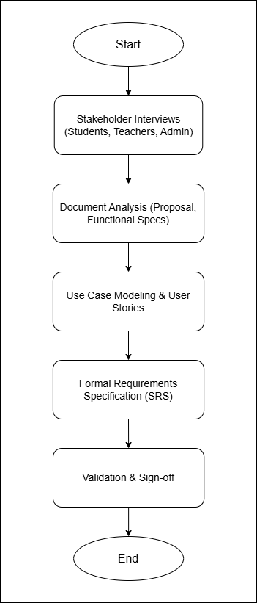
Figure 3.1: Requirements Gathering Process

Functional Requirements
Functional requirements are categorized by the core modules of the AI-Driven Smart LMS.

User Management Module
This module handles the registration, authentication, and profile management of all system users (Students, Teachers, Administrators).

ID | Requirement Description | Priority | Module
UM-01 | System shall allow new users to register by providing name, email, role, and facial data. | High | User Management
UM-02 | Admin shall be able to approve or reject pending user registrations. | High | User Management
UM-03 | System shall allow users to log in using face recognition via webcam. | High | User Management
UM-04 | System shall provide a "Forgot Password" mechanism for secondary, email-based authentication. | Medium | User Management
UM-05 | Admin shall be able to view, search, filter, and deactivate all user accounts. | High | User Management
UM-06 | Users shall be able to view and update their personal profile information (excluding immutable system fields). | Medium | User Management
Table 3.1: User Management Functional Requirements

Face Recognition Attendance Module
This module automates the process of student identification and attendance logging using biometric verification.

ID | Requirement Description | Priority | Module
FR-01 | System shall capture real-time video stream from a webcam at designated entry points or via the student portal. | High | Face Recognition
FR-02 | System shall process the video feed to detect a face and match its features against the pre-registered facial data in the database. | High | Face Recognition
FR-03 | Upon successful match, the system shall automatically create a "Present" attendance record for the student in the relevant class for the current day/time. | High | Face Recognition
FR-04 | System shall be capable of detecting and handling scenarios with multiple faces in frame, requesting the subject to be alone for verification. | Medium | Face Recognition
FR-05 | The face recognition algorithm shall be robust enough to work adequately under varying lighting conditions. | Medium | Face Recognition
FR-06 | Admin and Teachers shall be able to generate and view detailed attendance reports (daily, weekly, monthly) with filters for class, student, and date range. | High | Face Recognition
Table 3.2: Face Recognition Requirements

AI Chatbot Module
This module provides an intelligent, conversational interface for academic and administrative support.

ID | Requirement Description | Priority | Module
CB-01 | The chatbot shall understand and answer queries related to academic content, course schedules, deadlines, and syllabus. | High | Chatbot
CB-02 | The chatbot shall provide information about campus facilities, rules, and events. | High | Chatbot
CB-03 | The chatbot shall process natural language input (text) from users and respond in a conversational manner. | High | Chatbot
CB-04 | Upon receiving a subject/topic name, the chatbot shall generate multiple-choice questions (MCQs) with correct answers for self-assessment. | High | Chatbot
CB-05 | The chatbot shall, where applicable, provide hyperlinks to relevant course materials, lecture notes, or external resources. | Medium | Chatbot
CB-06 | The chatbot service shall be available 24/7, independent of teacher availability. | High | Chatbot
Table 3.3: AI Chatbot Requirements

Course Management Module
- FR-CM-01: Admin shall create and manage "Class" entities by linking Course, Section, and Semester.
- FR-CM-02: Admin shall enroll students into classes in bulk.
- FR-CM-03: Teacher shall upload, organize, and manage learning materials (PDFs, videos, slides) for their assigned classes.
- FR-CM-04: Students shall be able to view and download all materials for their enrolled classes.

Personalization Module
- FR-PM-01: System shall track student activity (login frequency, content access) and assessment performance.
- FR-PM-02: System shall analyze performance data to identify weak topics/subjects for each student.
- FR-PM-03: System shall automatically recommend specific study materials, practice quizzes, or external resources to address identified weaknesses.
- FR-PM-04: System shall display a personalized dashboard for each student highlighting progress, recommendations, and pending tasks.

Reporting & Analytics Module
- FR-RA-01: System shall generate graphical reports (charts, graphs) for student performance, attendance trends, and engagement metrics.
- FR-RA-02: Teachers shall have access to a dashboard showing aggregate and individual student analytics for their classes.
- FR-RA-03: Admin shall have a system-wide dashboard showing key performance indicators (KPIs) like total users, active classes, system health, etc.

Non-Functional Requirements
Non-functional requirements define the quality of service and system constraints.

Category | Requirement | Metric / Standard | Priority
Performance | Average page load time (dashboard) | < 3 seconds | High
 | Face recognition match response time | < 2 seconds | High
 | Chatbot query response time | < 1.5 seconds | High
Security | Encryption of sensitive data at rest | AES-256 algorithm | High
 | Authentication for system access | Face Recognition + Fallback Password/OTP | High
 | Protection against common web vulnerabilities (SQLi, XSS) | OWASP Top 10 compliance | High
Usability | System intuitiveness for primary tasks | >85% of users complete core tasks without help | High
 | Interface responsiveness on mobile browsers | Fully functional on screens ≥5 inches | Medium
Reliability | System operational availability | ≥ 99% during academic hours | High
 | Mean Time Between Failures (MTBF) for core modules | > 720 hours | High
Scalability | Support for concurrent active users | Up to 1000 users | Medium
 | Database performance | Support up to 10,000 student records with sub-3s query time | Medium
Maintainability | Code documentation coverage | ≥ 70% of backend API functions | Medium
Table 3.4: Non-Functional Requirements
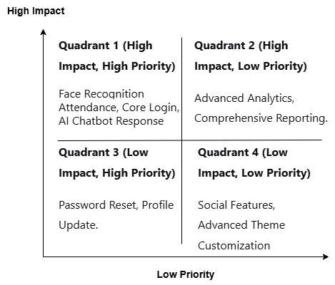
  - Prioritization Matix
Figure 3.2: Requirements Prioritization Matrix

Use Case Modeling

Use Case Diagram
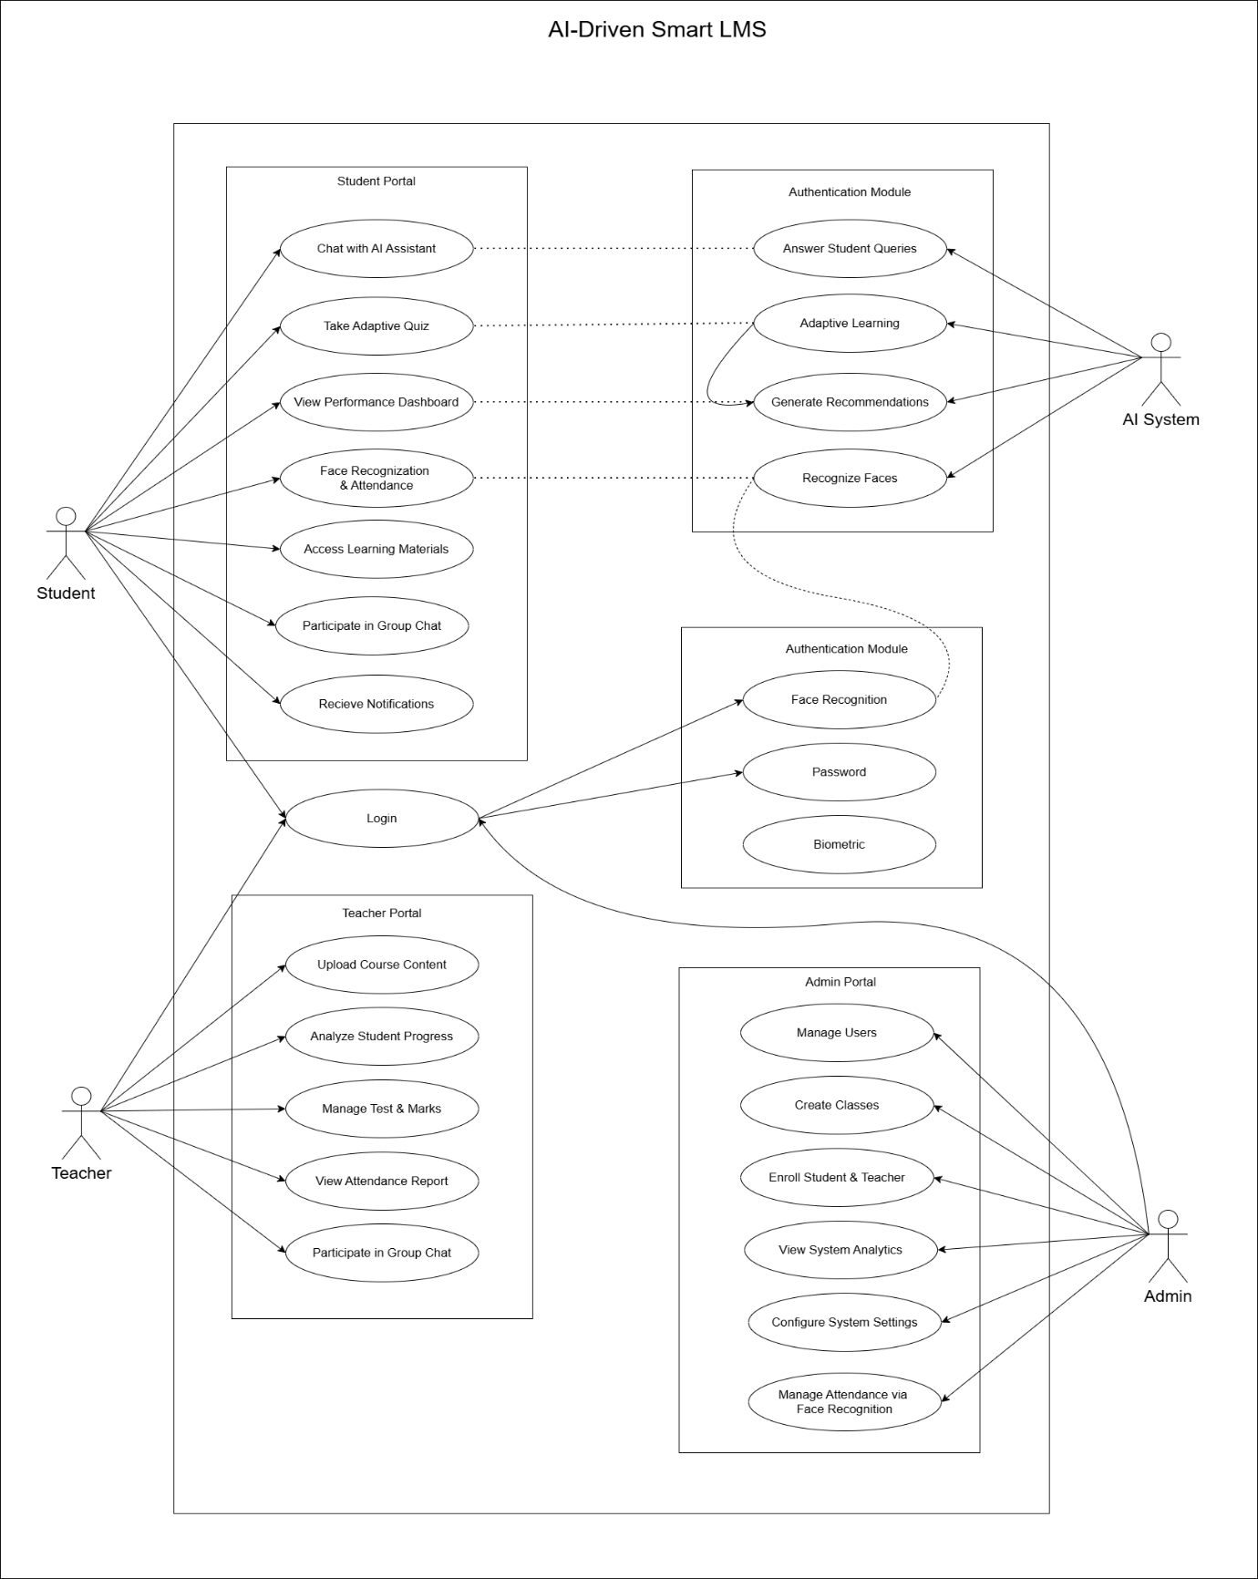
Figure 3.3: Use Case Diagram
- Actors: Admin, Teacher, Student, AI System.
- Admin Use Cases: Manage Users, Manage Classes, Generate Reports, Control Hardware.
- Teacher Use Cases: Upload Content, View Attendance Reports, Monitor Performance, Use Group Chat.
- Student Use Cases: Access Course Material, Interact with Chatbot, View Personalized Dashboard, Participate in Group Chat.
- AI System Use Cases: Recognize Face, Generate MCQ, Provide Chat Response, Analyze Performance.

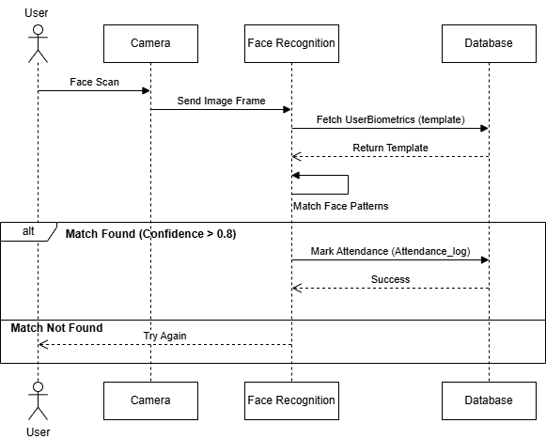
Detailed Use Case Specifications
Figure 3.4: Face Recognition Use Case Diagram

Academic Assistance from AI Chatbot
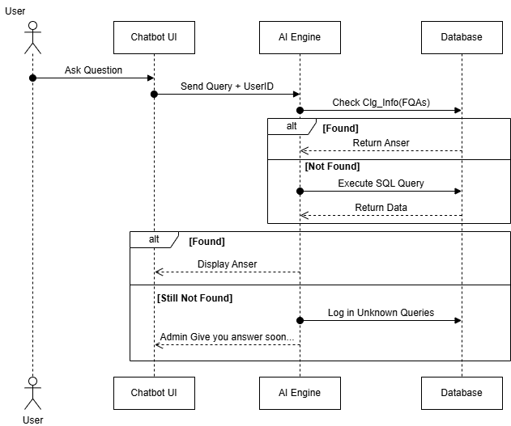
Figure 3.5: Get Academic Assistance from AI Chatbot

User Stories
ID | As a... | I want to... | So that...
01 | Student | have my attendance marked automatically when I walk into class | I don't have to manually sign in, saving time and ensuring accuracy.
02 | Student | ask an AI chatbot questions anytime | I can get immediate help with my studies, even outside teacher's office hours.
03 | Teacher | see a dashboard of which topics my students are struggling with | I can adjust my teaching focus and provide targeted support.
04 | Admin | easily enable/disable the campus entry cameras | I can control the system's hardware and manage security zones.
05 | Student | get personalized quiz suggestions on my weak topics | I can practice efficiently and improve my understanding.
Table 3.5: Sample User Stories

Hardware & Software Requirements

Hardware Required
Component | Minimum Requirement (Development) | Recommended (Production Deployment)
Server
Processor | 4-core CPU (Intel i5 / AMD Ryzen 5) | 8-core CPU (Intel i7 / AMD Ryzen 7)
RAM | 8 GB | 16 GB or higher
Storage | 100 GB HDD | 500 GB SSD (for OS, DB, Logs)
OS | Ubuntu 20.04 LTS / Windows Server 2019 | Ubuntu 22.04 LTS
Client/User
Processor | Dual-core 1.8 GHz | Intel i3 / AMD equivalent or better
RAM | 4 GB | 8 GB
Webcam | Integrated 720p | External 1080p Webcam
Browser | Chrome 80+, Firefox 75+, Edge 80+ | Latest stable version of major browsers
Internet | 5 Mbps | 10+ Mbps for smooth video streaming (Face Recognition)
Table 3.6: Development & Deployment Environment Requirements

Software/Technology Stack
Layer | Technology / Tool | Version / Purpose
Frontend | React.js | 18.x - Building interactive user interfaces
 | Tailwind CSS | 3.x - Utility-first CSS framework for styling
 | Axios | HTTP client for API communication
Backend | Python | 3.9+ - Core programming language
 | FastAPI | Modern, fast web framework for APIs
 | Uvicorn | ASGI/WSGI server for production
 | SQLAlchemy | ORM for database interactions
Database | MySQL | 8.0 - Relational database for structured data
 | Redis (Optional) | Caching for session and frequent data
AI/ML | OpenCV | 4.x - Real-time face detection and recognition
 | Transformers (Hugging Face) / OpenAI API | NLP for chatbot intelligence
 | Scikit-learn / Pandas | For recommendation engine and data analysis
DevOps & Tools | Git / GitHub | Version control and collaboration
 | Docker | Containerization for consistent environments
 | VS Code | Integrated Development Environment (IDE)
 | Postman | API testing and documentation
 | Draw.io | For creating system diagrams and flowcharts
Table 3.7: Software/Technology Stack

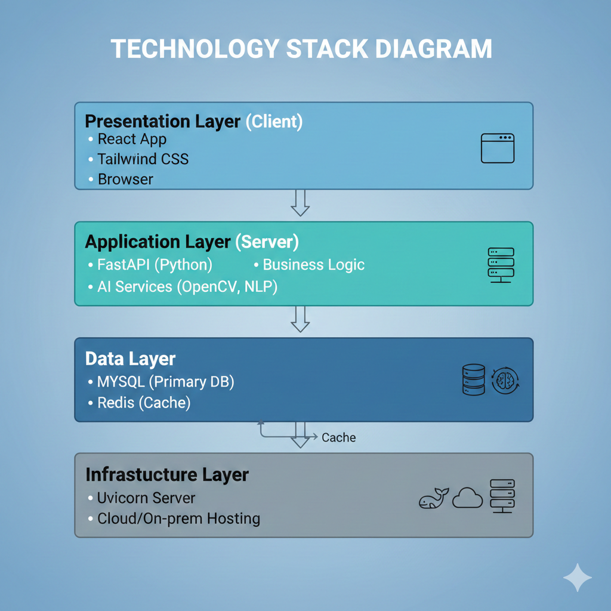
Figure 3.6: Technology Stack Diagram

Assumptions and Constraints
ID | Assumption | Impact if False / Mitigation
01 | All target users (students/teachers) will have access to a device with a functional webcam. | Attendance module becomes unusable; need to implement a manual fallback (e.g., QR code).
02 | The educational institution has stable internet connectivity for the server and major client locations. | Core cloud-based features will be inaccessible; may require an offline mode for content access.
03 | Users possess basic digital literacy to navigate a web portal. | Will increase support burden and require creation of detailed user guides/tutorials.
04 | The university administration supports the deployment of AI and biometric data collection, adhering to privacy laws. | Project deployment may be blocked; requires clear privacy policy and data handling documentation from the start.
05 | The initial dataset of student faces for training/registration will be provided or collected ethically. | The face recognition system cannot be initialized.
Table 3.8: Assumptions and Constraints

CHAPTER 4: SYSTEM DESIGN

4.1 Design Principles & Methodology

4.2 System Architecture
4.2.1 High-Level Architecture Diagram (Figure 4.1)
4.2.2 Technology Stack (Frontend, Backend, Database, APIs)

4.3 Data Design
4.3.1 Entity-Relationship (ER) Diagram (Figure 4.2)
4.3.2 Database Schema (Tables with columns, datatypes, PK/FK) Table 4.1

4.4 Process Design
4.4.1 Data Flow Diagrams (DFD Level 0 & Level 1) (Figure 4.3, 4.4)
4.4.2 Sequence Diagrams (for 2-3 key processes) (Figure 4.5)
4.4.3 Activity / Flowchart (for complex logic) (Figure 4.6)

4.5 Class Diagram (Object-Oriented Design) (Figure 4.7)

4.6 UI/UX Design
4.6.1 Wireframes / Mockups (Figure 4.8)
4.6.2 Navigation Flow

CHAPTER 5: IMPLEMENTATION & DEVELOPMENT

5.1 Development Setup

5.2 Module Implementation
5.2.1 User Authentication Module
5.2.2 [Your Main Feature 1] Module
5.2.3 [Your Main Feature 2] Module
5.2.4 Database Connectivity

5.3 Code Snippets with Explanation (Important algorithms/functions ke 2-3 snippets)

5.4 Integration of Components

5.5 Challenges Faced & Solutions

CHAPTER 6: TESTING & VALIDATION

6.1 Testing Strategy & Types (Unit, Integration, System)

6.2 Test Environment Setup

6.3 Test Cases & Results
6.3.1 Functional Test Cases (Table 6.1)
6.3.2 UI/Usability Test Cases (Table 6.2)
6.3.3 Security Test Cases (Table 6.3)

6.4 Sample Test Output Screenshots (Pass/Fail) (Figure 6.1, 6.2, etc.)

6.5 Bug Report & Tracking (Ek small table agar bugs fix kiye)

6.6 Testing Summary

CHAPTER 7: RESULTS & DISCUSSION

7.1 System Screenshots (Final working system ke 8-10 screenshots with captions)

7.2 Demonstration of Key Features

7.3 Achievement of Objectives (Chapter 1 ke objectives ke against check karen)

7.4 Performance Evaluation (Response time, accuracy, etc. agar applicable ho)

7.5 User Feedback (Agar kisi se testing karwai hai to)

CHAPTER 8: CONCLUSION & FUTURE WORK

8.1 Conclusion (Project ka summary, kya seekha)

8.2 Limitations (Jo abhi implement nahi ho paya ya constraints the)

8.3 Future Enhancements (Aage kya improve kar sakte hain)

8.4 Applications & Social Impact (Real-world use)

BACK MATTER (Peeche ke Pages)

9. References / Bibliography (IEEE ya APA format use karen)

10. Appendices

Appendix A: Complete Source Code (GitHub repo link dena better hai)

Appendix B: User Manual (Step-by-step how to install and run)

Appendix C: Additional Diagrams or Data

Appendix D: Research Papers (agar use kiye hain to)

